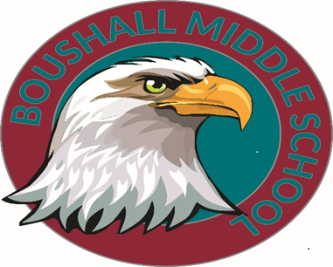

April 21st, 2023

Dear Parents/Guardians,
Many of our 6th Grade scholars are looking forward to the last week of school and moving on to 7th grade next school year. Students have been working extremely hard all year, and we would like to celebrate their accomplishments. This week of fun will take place during the last week of school, beginning Monday, June 5, 2023, and ending on Thursday, June 8, 2023. We are making every effort to reduce the total cost of these events; however, there will be some family financial responsibility for these activities. Please see the attached breakdown of costs.
Please note that the Student Code of Responsible Ethics applies during all events. Our intent is to make all activities accessible for ALL scholars. For this reason, your scholar may be required to have a personal, administration-approved chaperone over 18 if behavior and conduct have been a recurring issue. Additionally, the school administration may provide an alternate activity for scholars in lieu of the planned activities if deemed necessary.
Attached to this letter is a list of activities, dates, and prices. Dates are subject to change based on availability. Payments for these events will be accepted from April 24th, 2023, to May 26, 2023. Please do not hesitate to contact us if you need further clarification or assistance.
Mrs. Williams (formally known as Steele), the 6th-grade team lead, can be reached via email at psteele@rvaschools.net, Dr. Patricia Aldridge, the 6 th grade assistant principal paldridg@rvaschools.net. All previously mentioned parties can be contacted at (804) 780-5016.

Sincerely,
The 6th Grade Team

6th Grade End of The Year Activities
Date | Activity | Description of Activity | Price
Monday-  June 5th, 2023 | Sixth Grade  Field Trip | The Coach bus will depart at 8:45 am from the school and return to school by 3:00 pm.  The total cost covers admission tickets and the Safari ride. As well as covers the charter that will transport us.  Students can have school-supplied bag lunch or bring money to the concession stand. | $36
Tuesday-  June 6th, 2023 | Sixth Grade  Award Ceremony & Movie Day | Doors will open promptly at 10:10 am, and the ceremony will start promptly at 10:25 am.  Students will be recognized for Perfect Attendance, Honor & Scholar Roll, & Class Superlatives, etc.  Parents are welcome to come in person or virtually via Facebook Live. | No cost
Wednesday-  June 7th, 2023 | Sixth Grade  Field Day | A day filled with food, activities/games, & a good time!  Parents/ Guardians are invited to attend and sign in through the front office with proper ID. | $5.00 (lunch, snacks, & activities)
Thursday-  June 8th, 2023 | Sixth Grade  Station Day | Students sign up for different activities per subject. Each content has a theme/activity, and the students will complete the engaging task. | Free
Friday-  June 9th, 2023 | Last Day of School | Two-hour early release. Students will leave at 1:15 pm. | Free
**All money for the activities above is due by Tuesday, May 30, 2023. **
Payments may be made online using the following link below:
https://osp.osmsinc.com/RichmondVA/
-Click “Middle School” at the top of the page
-Select “Boushall” on the left-hand side
-Select 6th-grade options to pay

