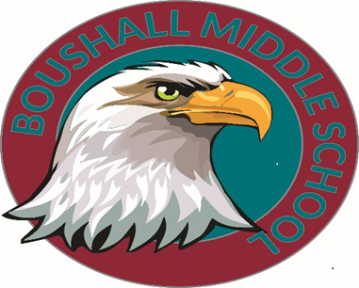

April 21st, 2023

Dear Parent/Guardian,
As you know, many of our 7th Grade scholars are looking forward to the last week of school and their moving on to 8th grade next school year. Students have been working extremely hard all year and we would like to celebrate their accomplishments. This week of fun will take place during the last week of school beginning Monday, June 5, 2023, and ending on Thursday, June 8, 2023. We are making every effort to reduce the total cost of these events; however, there will be some family financial responsibility for these activities. Please see the attached breakdown of costs.
Please note that the Student Code of Responsible Ethics applies during all events. Our intent is to make all activities accessible for ALL scholars. For this reason, your scholar may be required to have a personal, administration-approved chaperone that is over the age of 18, if behavior and conduct have been a recurring issue. Additionally, the school administration may provide an alternate activity for scholars in lieu of the planned activities, if deemed necessary.
Attached to this letter is a list of activities, dates, and prices. Dates are subject to change based on availability. Payments for these events will be accepted from April 24th, 2023, to May 26, 2023. Please do not hesitate to contact us if you need further clarification or assistance.
Mrs. Gray-Reynolds, the 7th grade team lead, can be reached via email at kreynolds@rvaschools.net, Mrs. Kiara Jones, the 7th grade administrative aide kjones14@rvaschools.net. All previously mentioned parties can be contacted at (804) 780-5016.

Sincerely,
The 7th Grade Team

7th Grade End of The Year Activities
Date | Activity | Description of Activity | Price
Monday  June 5, 2023 | Kings Dominion | Students will ride a school bus to Kings Dominion for a day of fun at their amusement and water park. Students will have the option to purchase a meal at the park and must bring extra money about $15.00 or take a bagged lunch from the cafeteria. Students who have a valid season pass may use it instead of purchasing a ticket. We will depart Boushall Middle School on a chaperoned bus at 10:00 am and return at 6:00 pm. Students must be picked up no later than 6:00pm. | $63  ($38 park ticket without a season pass & $25 transportation)  $25  (with a season pass)
Tuesday  June 6, 2023 | 7th Grade Field Day | There will be food, games and fun! Parents/Guardians are invited to attend and sign-in through the front office with the proper ID. | $5.00 (lunch, cotton candy, popcorn, & activities)
Wednesday  June 7, 2023 | Awards Ceremony  & Movie Day | Doors will open at 9:00 am and the ceremony will begin promptly at 9:15 AM. Students will be recognized for the following: Perfect Attendance, Honor & Scholar Roll, & Class Superlatives and others. Parents are invited to attend in-person or virtually via Facebook Live. | No Cost
Thursday  June 8, 2023 | Game Day  & Ice Cream Social | Students will participate in games/stations organized by their teacher. With the opportunity to have a sweet treat after lunch sponsored by the 7th grade team. | $2.00 (ice cream and toppings)

**All money for the activities above is due by Tuesday, May 30, 2023. **
- Payments may be made online using the following link below:
https://osp.osmsinc.com/RichmondVA/
-Click “Middle School” at the top of the page
-Select “Boushall” on the left hand side
-Select the 7th grade options to pay

